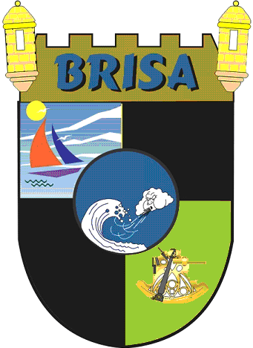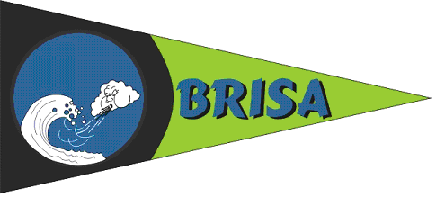
BoRinquen Islands Sailing Association
BRISA
www.brisaweb.net

March 20, 2014

NOR Amendment 1

The Skipper Meeting will be at 7:00 pm due to Rock Band Concert at 8:00 pm

David Kerr

Race Committee Chairman

